Name: __________________________________________________________________ Period: ______________

1. Where did you locate your civilization?

* next to an ocean 
* in the mountains 
* on an island 
* in the rainforest 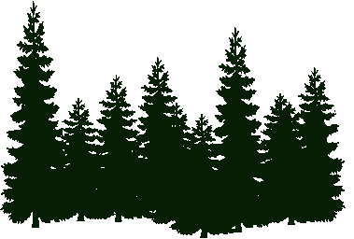
* next to a river 
* in the desert 

1. Why did you locate your civilization there?

____________________________________________________________________________________________________________________________________________________________________________________________________________________________________________________________________________________________________________________________________________________________________________________________________________________________________________________________________________________________________________________________________________________________________________________________________________

1. How did you spend your 20 Resource Points on animals?

_______ camels 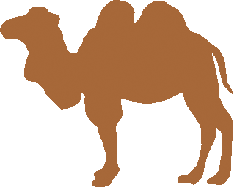

_______ cats 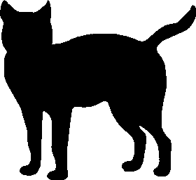

_______ chickens 

_______ cows 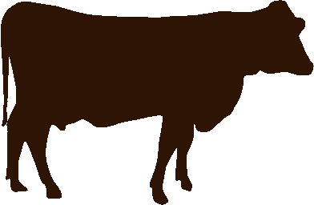

_______ dogs 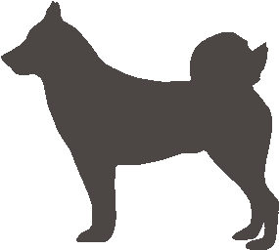

_______ fish 

_______ horses 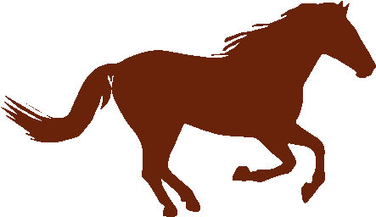

_______ llamas 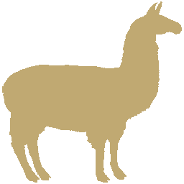

1. Why did you choose those animals?

____________________________________________________________________________________________________________________________________________________________________________________________________________________________________________________________________________________________________________________________________________________________________________________________________________________________________________________________________________________________________________________________________________________________________________________________________________

1. How did you spend your 20 Resource Points on plants?

_______ beans 

_______ corn 

_______ oranges 

_______ pine trees 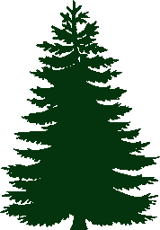

_______ potatoes 

_______ roses 

_______ wheat 

1. Why did you choose those plants?

__________________________________________________________________________________________________________________________________________________________________________________________________________________________________________________________________________________________________________________________________________________________________________________________________________________________________________________________________________________________________________

1. How did you spend your 10 Resource Points on materials?

_______ bronze 

_______ gold 

_______ iron 

_______ silk 

_______ stone 

1. Why did you choose those materials??

__________________________________________________________________________________________________________________________________________________________________________________________________________________________________________________________________________________________________________________________________________________________________________________________________________________________________________________________________________________________________________

1. Were you surprised by any of the resource bonus values? Why?

__________________________________________________________________________________________________________________________________________________________________________________________________________________________________________________________________________________________________________________________________________________________________________________________________________________________________________________________________________________________________________

1. What was the best event that happened in **Year 1**? What was the worst?

________________________________________________________________________________________________________________________________________________________________________________________________________________________________________________________________________________________________________________________________________________________________________________________________________

1. Did your population shrink or grow in **Year 1**? How many civilians did you end with?

______________________________________________________________________________________________________________________________________________________________________________________________________________________________________________________________________________________________________

1. What happened during your first war in **Year 3**? Did any of your huts survive?

______________________________________________________________________________________________________________________________________________________________________________________________________________________________________________________________________________________________________

1. What happened during the Events round in **Year 4**?

______________________________________________________________________________________________________________________________________________________________________________________________________________________________________________________________________________________________________

1. At the end of **Year 7**, what is your most valuable resource? What about your least valuable resource? Why?

__________________________________________________________________________________________________________________________________________________________________________________________________________________________________________________________________________________________________________________________________________________________________________________________________________________________________________________________________________________________________________

1. What happened during the Events round in **Year 10**?

______________________________________________________________________________________________________________________________________________________________________________________________________________________________________________________________________________________________________

1. In what year did your population reach 100,000 civilians? In a complete paragraph below, explain what you think led to your success, and what you would do differently with a new civilization.

____________________________________________________________________________________________________________________________________________________________________________________________________________________________________________________________________________________________________________________________________________________________________________________________________________________________________________________________________________________________________________________________________________________________________________________________________________________________________________________________________________________________________________________________________________________________________________________________________________________________________________________________________________________________________________________________________________________________________________________________________________________

__________________________________________________________________________________________________________________________________________________________________________________________________________________________________________________________________________________________________________________________________________________________________________________________________________________________________________________________________________________________________________

________________________________________________________________________________________________________________________________________________________________________________________________________________________________________________________________________________________________________________________________________________________________________________________________________